**Coding Contribution Release 1**

Team 14 – Community Organization (Yee Chen Fong n9602976)

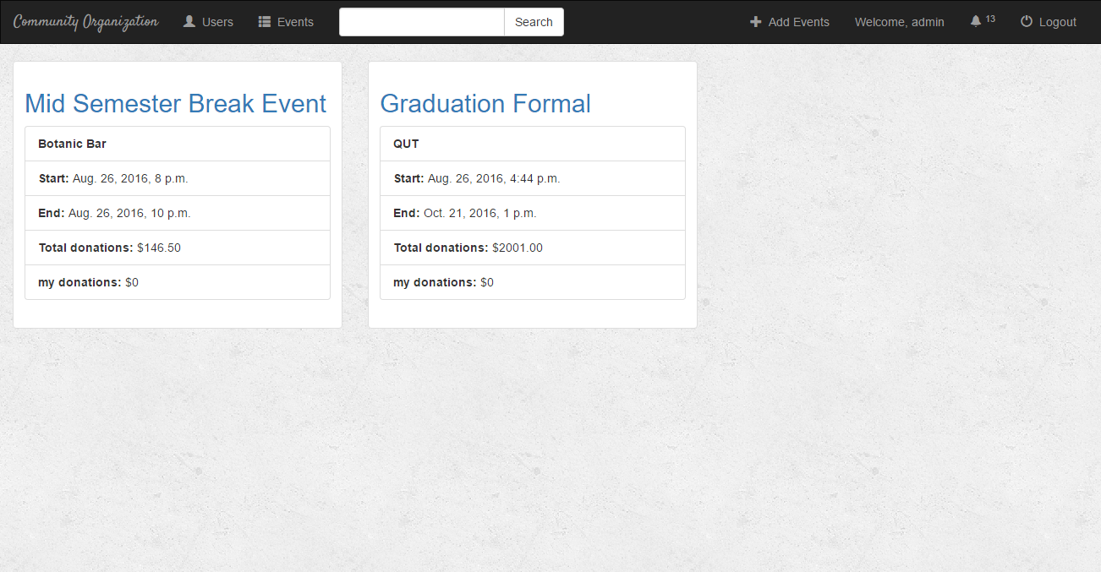

**Figure 1. Event Page (eventIndex.html)**

The Main contribution I made during Release 1 is designing and coding the header of the website. The links I have design and coded (with help from teammates) include:

* Logo
* Users
* Events
* Search Bar
* Add events
* Function to display current user’s name
* Notification
* Logout/Login

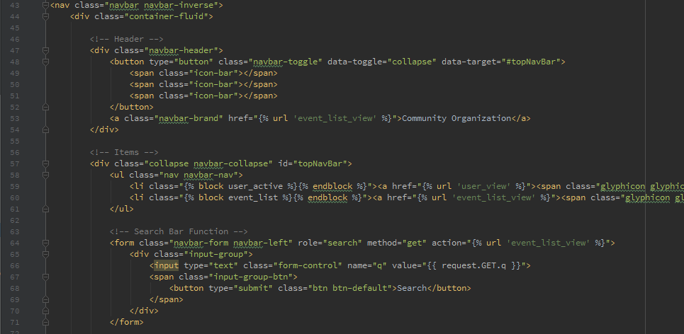

**Figure 2.1. Contributions in Header (base.html)**

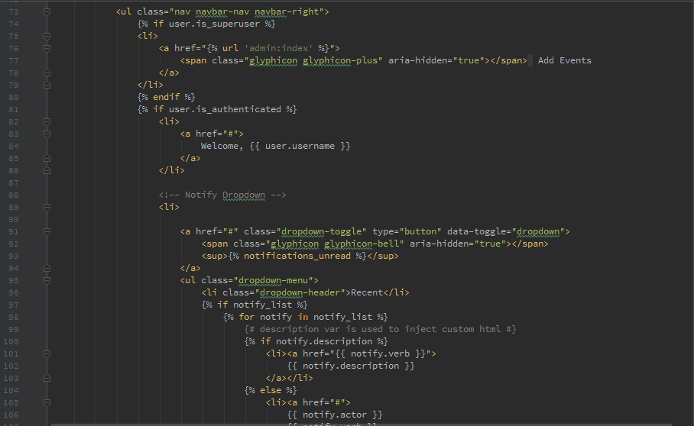

**Figure 2.2. Contributions in Header (base.html)**

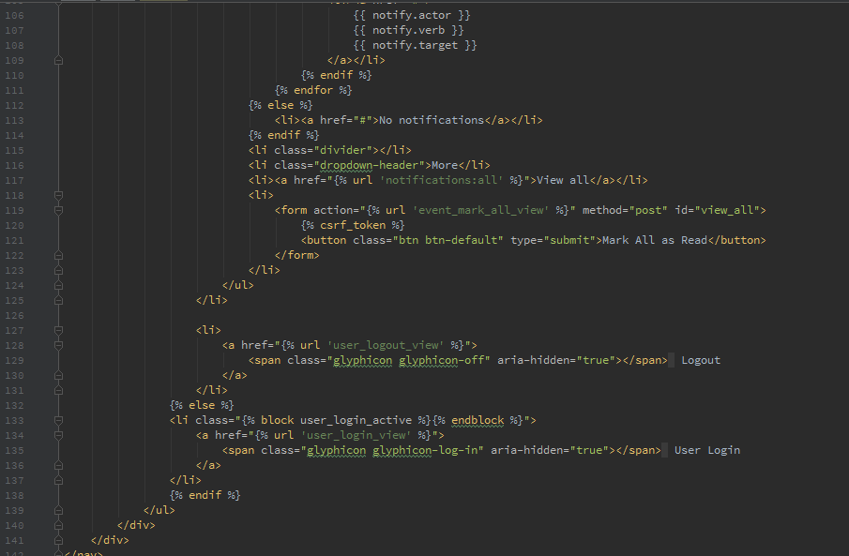

**Figure 2.3. Contributions in Header (base.html)**

I have contributed by helping coding the arrangement the list of events in the events page. Features include:

* The ‘Attending’, ‘Volunteering’ title
* Arrangements of events

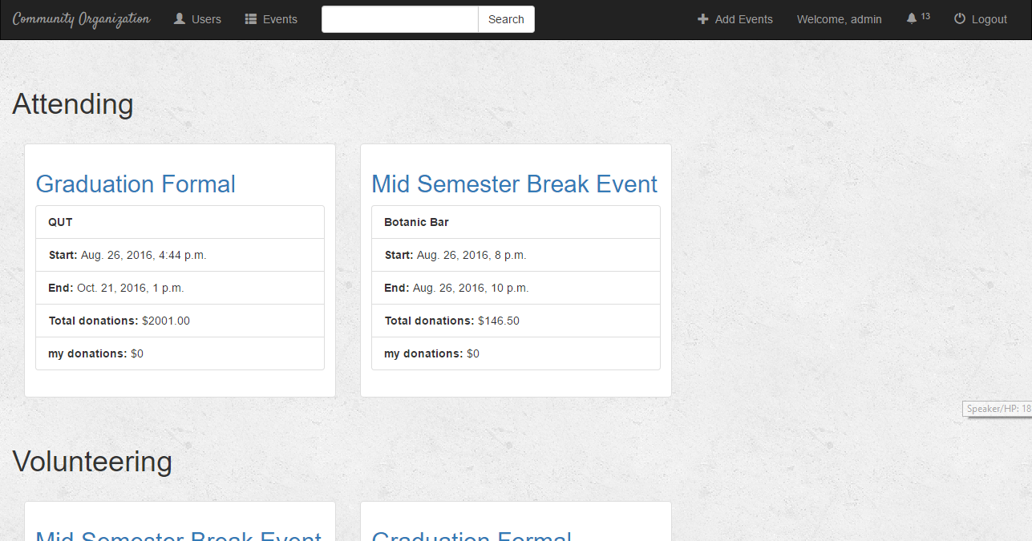

**Figure 3. Users Page (users.html)**

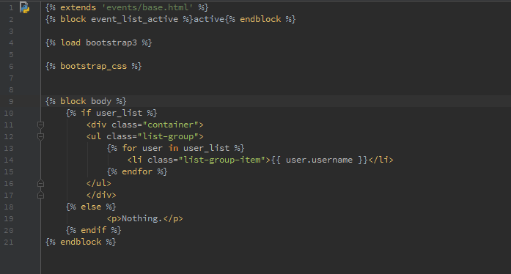

**Figure 4. Involvement in coding users.html**

I have also contributed coding the Volunteering and Attending List for each events.

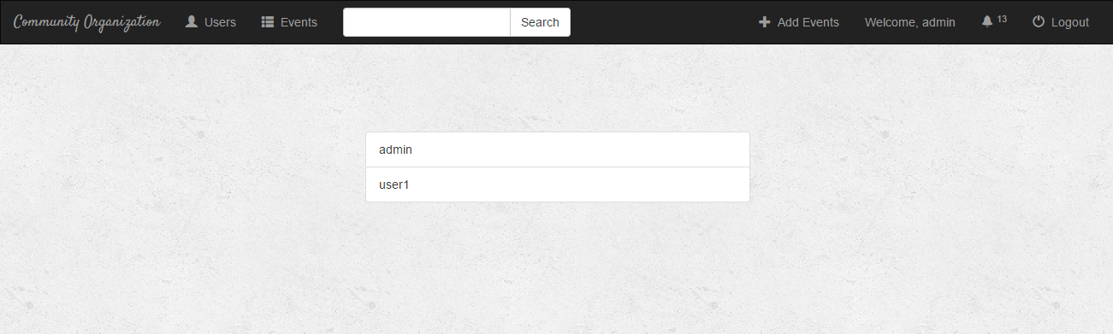

**Figure 5. Attendance List (eventUsers.html)**

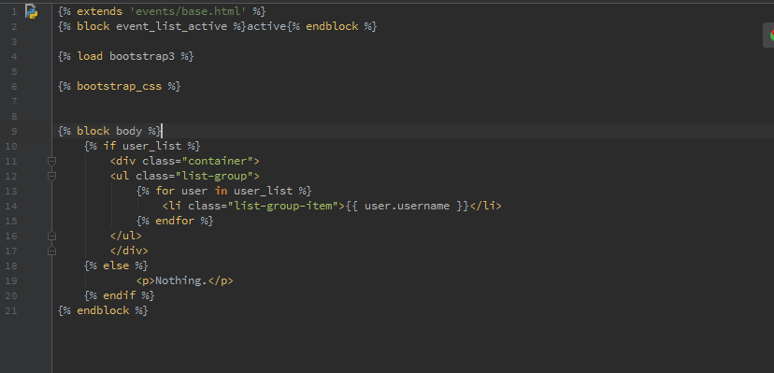

**Figure 6. Involvement in coding eventUsers.html**